|  |
| --- |
| E-mail Address: [cics.alangilan@g.batstate-u.edu.ph | Website Address:](mailto:cics.alangilan@g.batstate-u.edu.ph%20|%20Website%20Address:%20) [http://www.batstate-u.edu.ph](http://www.batstateu-u.edu.ph) **Golden Country Homes, Alangilan Batangas City, Batangas, Philippines 4200 The National Engineering University**  Tel Nos.: (+63 43)425-0139 local 2222 / 2223  **Alangilan Campus**  **Republic of the Philippines**  **BATANGAS STATE UNIVERSITY** |

**College of Informatics and Computing Sciences**

**GUIDE**   
**( Goals for Understanding and Improving Daily Education ) Documentation**   
CS121: ADVANCED COMPUTER PROGRAMMING

Submitted By:   
BEDAR, JOMAR ICHIRO M.

IT – 2101

***Leading Innovations, Transforming Lives, Building the Nation***

|  |
| --- |
| E-mail Address: [cics.alangilan@g.batstate-u.edu.ph | Website Address:](mailto:cics.alangilan@g.batstate-u.edu.ph%20|%20Website%20Address:%20) [http://www.batstate-u.edu.ph](http://www.batstateu-u.edu.ph) **Golden Country Homes, Alangilan Batangas City, Batangas, Philippines 4200 The National Engineering University**  Tel Nos.: (+63 43)425-0139 local 2222 / 2223  **Alangilan Campus**  **Republic of the Philippines**  **BATANGAS STATE UNIVERSITY** |

**College of Informatics and Computing Sciences**

**I. PROJECT OVERVIEW**

Proper time management is key to success in college. People need to manage time effectively if they aim to be successful one day. Time management is very important and it may actually affect individual's overall performance and achievements. People especially students nowadays always commented that they do not have enough time to complete all the tasks assigned to them. In addition, a university environment's flexibility and freedom can derail students who have not mastered time management skills. I have created an app called GUIDE or“Goals for Understanding and Improving Daily Education”, this is a to-do list app with an integrated pomodoro timer and a music player that can be played in the background in order for the user to be more focused on doing their tasks. .

So why does this app or system exists in the first place? This app primarily focuses on improving the attention span of a struggling student that makes their simple task a difficult one by procrastinating and not finishing tasks on time. This system ensures on giving out the simplicity to a task and maximizing effort of students by making them create and manage their own task to improve their focus and education. The simplification of the graphical user-interface that the user/student will use is very straight forward and very easy to use therefore there will be no confusion, errors or any faults while using the system.

The general objective of this system is make an improvement for making a to-do list. To ensure that the user don’t have to go pick any time-related application one by one this system ensures that it will be an all-in-one package for the users to access. The focus here is to help the students improve their quality education by making them study more and procrastinate less, because nowadays there are so many distractions that led students to lose focus and not study at all, this system is major improvement for the students to use on their daily routine or study.

**Included Features**   
 The system focuses on creating a to-do list for the users to use on a daily basis. The system already have an integrated timer that uses the time management method **“Pomodoro Timer”** where the user is set to do the task on a given time, like in this program the timer is set to 25 minutes of work timer while that timer is running the user is not allowed to stop doing their task until that timer is finished. The good thing is that when finishing the countdown of the timer the user is rewarded a 5 minute break, it might not seem worth it but people tend to lose focus when they get too comfortable on not doing their task, that is why 5 minutes is enough for them to still have the urge to finish their task. But worry not, the system also has an integrated music player that plays calming Lo-Fi beats on the background making sure the user is relaxed and calm on the entire process of doing their own task. The users here will have a great time making their task because this system simplify things so that making a to-do list will not make their study plans or plans overly complicated. The GUI of this program is not hard on the eyes and it is created to be in a soothing environment that makes the user feel at ease.

***Leading Innovations, Transforming Lives, Building the Nation***

|  |
| --- |
| E-mail Address: [cics.alangilan@g.batstate-u.edu.ph | Website Address:](mailto:cics.alangilan@g.batstate-u.edu.ph%20|%20Website%20Address:%20) [http://www.batstate-u.edu.ph](http://www.batstateu-u.edu.ph) **Golden Country Homes, Alangilan Batangas City, Batangas, Philippines 4200 The National Engineering University**  Tel Nos.: (+63 43)425-0139 local 2222 / 2223  **Alangilan Campus**  **Republic of the Philippines**  **BATANGAS STATE UNIVERSITY** |

**College of Informatics and Computing Sciences**

**Images of included features of To-do List:**

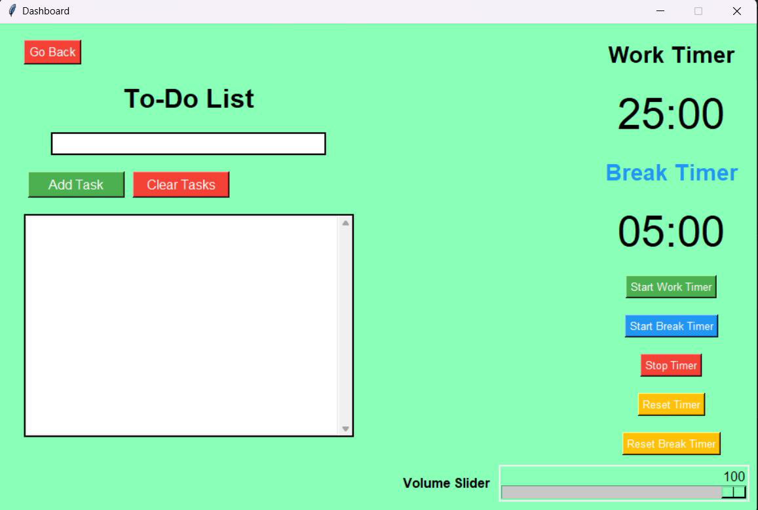

**Img. 1**

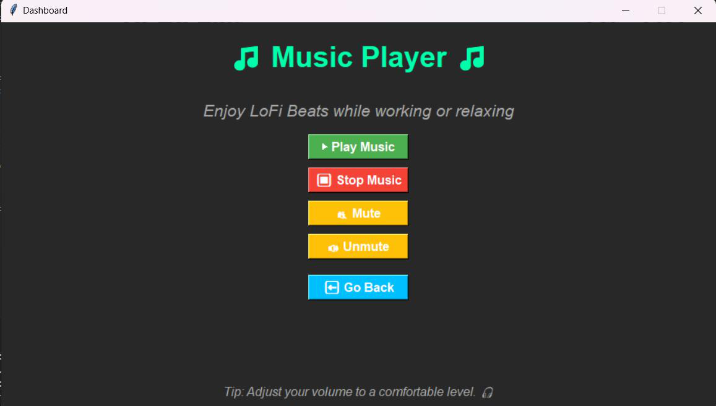

**Img. 2**

**Excluded Features**   
 The system have excluded the feature of making the user input their own time in the timer because the system encourages the user to try and be comfortable on the time management method called **“Pomodoro Technique”** or **“Pomodoro Timer”**. The system also don’t have a database to store the inputted task of each user because there will be times that the user will likely exit the app and not do their task because all the data or task is stored in the database and they will likely think that the task can be done later. Therefore, there is no database for all the task that has been inputted in the frame to avoid the avoidance of doing their task, but there is a warning for the user upon quitting the app this will likely make them think twice before they stop doing their task on time.

***Leading Innovations, Transforming Lives, Building the Nation***

|  |
| --- |
| E-mail Address: [cics.alangilan@g.batstate-u.edu.ph | Website Address:](mailto:cics.alangilan@g.batstate-u.edu.ph%20|%20Website%20Address:%20) [http://www.batstate-u.edu.ph](http://www.batstateu-u.edu.ph) **Golden Country Homes, Alangilan Batangas City, Batangas, Philippines 4200 The National Engineering University**  Tel Nos.: (+63 43)425-0139 local 2222 / 2223  **Alangilan Campus**  **Republic of the Philippines**  **BATANGAS STATE UNIVERSITY** |

**College of Informatics and Computing Sciences**

**Images of excluded features of To-do List:**

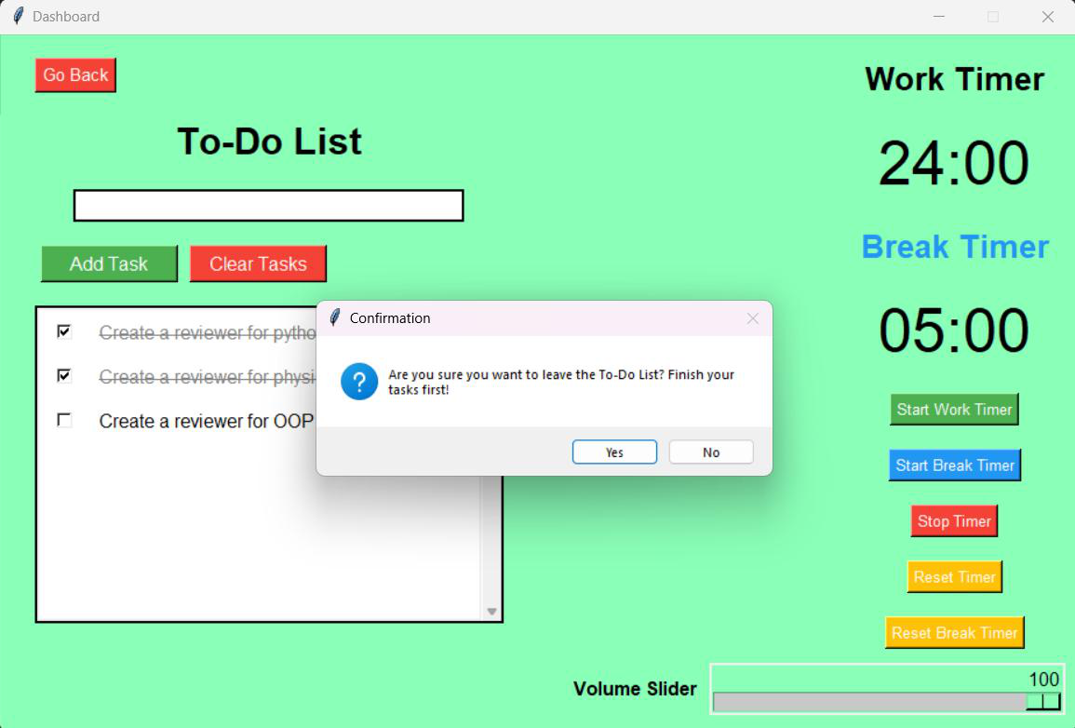

**Img. 3**   
**Target Users**   
 The target user’s here are those who are struggling to manage their time properly and help them stop procrastinating all the time they get a task. This system is also compatible for students to use on a daily basis because this system provides a multifunctional productivity tools that will ensure the students to remain focus at all times.

This system utilizes the SMART criteria effectively because everything we see in this program ensures that the student will be receiving their well-deserved outcomes by making the students do more workload than they usually do all the time. The system will surely help on reducing the anxiety on doing many task in a single day. But by having the patience to do all the task, this system makes sure that they stay focus and relax all the time by just using the system at its fullest. Making a to-list have never been easier, that’s because this system is a very user-friendly that is easy to interact and use.

***Leading Innovations, Transforming Lives, Building the Nation***

|  |
| --- |
| E-mail Address: [cics.alangilan@g.batstate-u.edu.ph | Website Address:](mailto:cics.alangilan@g.batstate-u.edu.ph%20|%20Website%20Address:%20) [http://www.batstate-u.edu.ph](http://www.batstateu-u.edu.ph) **Golden Country Homes, Alangilan Batangas City, Batangas, Philippines 4200 The National Engineering University**  Tel Nos.: (+63 43)425-0139 local 2222 / 2223  **Alangilan Campus**  **Republic of the Philippines**  **BATANGAS STATE UNIVERSITY** |

**College of Informatics and Computing Sciences**

**II. PYTHON CONCEPTS AND LIBRARIES**

**Python Tkinter**  
● Tkinter is the standard Python package for generating Graphical User Interfaces (GUIs).

It offers a variety of widgets (e.g., buttons, labels, text fields) and controls for developing desktop applications.

**Key Concepts and Functions:**

● Widgets are components used to communicate with users, such as buttons, labels, and entries.

● Window Management: Set the layout, geometry, and appearance of the program window.

● Event Handling: Use callback routines that are triggered by events (such as button clicks).

**Examples in code:**

|  |  |  |  |
| --- | --- | --- | --- |
| from tkinter import * | | | |
| window = Tk() | # Initialize the main application window | | |
| window.title('Dashboard') | | # Set the window title | |
| window.geometry('925x600+300+100') | | | # Specify size and position |

**Img. 4**

**Event-Driven Programming:**   
**Example:**

|  |  |
| --- | --- |
| |  | | --- | | Button(window, text="▶Play Music", command=play_music, bg="#4CAF50") | |

**Img. 5**

The command parameter specifies that the play_music function be executed when the button is clicked.

**Pygame for Multimedia and Music Playback**  
 ● Pygame is a library intended for multimedia applications like as games. It offers music playback, 2D graphics rendering, and other features.

**Key concepts:**  
 ● Mixer Module: Controls and plays back sounds.

● Playback Options:  
● play() starts audio playback.

set_volume(): Controls the audio volume.  
● stop(): Disables the audio.

***Leading Innovations, Transforming Lives, Building the Nation***

|  |
| --- |
| E-mail Address: [cics.alangilan@g.batstate-u.edu.ph | Website Address:](mailto:cics.alangilan@g.batstate-u.edu.ph%20|%20Website%20Address:%20) [http://www.batstate-u.edu.ph](http://www.batstateu-u.edu.ph) **Golden Country Homes, Alangilan Batangas City, Batangas, Philippines 4200 The National Engineering University**  Tel Nos.: (+63 43)425-0139 local 2222 / 2223  **Alangilan Campus**  **Republic of the Philippines**  **BATANGAS STATE UNIVERSITY** |

**College of Informatics and Computing Sciences**

**Examples in code:**

|  |  |  |  |  |
| --- | --- | --- | --- | --- |
| import pygame | | | | |
| pygame.mixer.init() | # Initialize the mixer module | | | |
| pygame.mixer.music.load("LoFi Beats.mp3") | | | | # Load the audio file |
| pygame.mixer.music.play(-1) | | # Loop the music indefinitely | | |
| pygame.mixer.music.set_volume(0.5) | | | # Set playback volume to 50% | |

**Img. 6**   
**MySQL Connector: Database Connectivity**  
 ● mysql.connector is a Python package for interacting with MySQL databases, allowing you to run queries, get data, and manage records.

**Key concepts:**  
 ● Connection Object: Creates a connection to the database.

● Cursor Object: Runs SQL operations and receives results.

● Transactions: Use commit() to store changes and rollback() to undo.

**Examples in code:**

|  |
| --- |
| import mysql.connector |

|  |  |
| --- | --- |
| connection = mysql.connector.connect( | |
| host='localhost', | # Database server |
| user='root', | # Username |
| password='1234', | # Password |

database='user_db' # Database name

|  |  |
| --- | --- |
| )  cursor = connection.cursor() | # Create a cursor for executing queries |

cursor.execute("SELECT session_id FROM Page_Session WHERE user_id = %s",

|  |  |
| --- | --- |
| (user_id,))  connection.commit() connection.close() | # Save changes  # Close the connection |

**Img. 7**

**Pillow (PIL): Image Processing**  
 ● Pillow (formerly known as PIL) is a Python Imaging Library that opens, manipulates, and saves images in a variety of formats.

**Key concepts:**  
 ● Image Handling:  
 ● Image.open() loads an image file.

● ImageTk.PhotoImage converts images for usage in Tkinter.

Animation:  
● ImageSequence.Iterator: Extracts frames from GIFs to render.

***Leading Innovations, Transforming Lives, Building the Nation***

|  |
| --- |
| E-mail Address: [cics.alangilan@g.batstate-u.edu.ph | Website Address:](mailto:cics.alangilan@g.batstate-u.edu.ph%20|%20Website%20Address:%20) [http://www.batstate-u.edu.ph](http://www.batstateu-u.edu.ph) **Golden Country Homes, Alangilan Batangas City, Batangas, Philippines 4200 The National Engineering University**  Tel Nos.: (+63 43)425-0139 local 2222 / 2223  **Alangilan Campus**  **Republic of the Philippines**  **BATANGAS STATE UNIVERSITY** |

**College of Informatics and Computing Sciences**

**Examples in code:**

|  |  |
| --- | --- |
| from PIL import Image, ImageTk, ImageSequence | |
| gif = Image.open("Dog Study.gif") | # Open a GIF |

|  |  |
| --- | --- |
| frames = [ImageTk.PhotoImage(frame.copy()) for frame in | |
| ImageSequence.Iterator(gif)] | # Extract frames |

**Img. 8**

**Datetime: Time Management**  
 ● A built-in Python module for working with dates and times is called datetime. It is capable of performing arithmetic, formatting, and parsing operations on timestamps.

**Key Concepts:**  
 ● The current local date and time are returned by datetime.now().

● Datetime objects are formatted by converting them to strings for display.

● SQL Integration: The current timestamp is captured for database storage by SQL's NOW() function.

**Examples in code:**

|  |
| --- |
| cursor.execute("UPDATE Page_Session SET end_time = NOW() WHERE |

|  |
| --- |
| from datetime import datetime |

|  |
| --- |
| session_id = %s", (session[0],)) |

**Img. 9**

**Canvas and Scrollable Widgets**  
 ● The Canvas widget in Tkinter allows you to draw shapes, photos, and embed other widgets. It is frequently paired with Scrollbar for dynamic content management.

**Key concepts:**

● Scrollable Content   
**Example in code:**

|  |
| --- |
| canvas = Canvas(task_list_frame, bg="#fff") scrollbar = |

|  |
| --- |
| Scrollbar(task_list_frame, orient=VERTICAL, command=canvas.yview) |

|  |
| --- |
| canvas.configure(yscrollcommand=scrollbar.set) |

**Img. 10**

● Dynamic Widget Embedding   
**Example in code:**

|  |
| --- |
| task_canvas_frame = Frame(canvas, bg="#fff") |

|  |
| --- |
| canvas.create_window((0, 0), window=task_canvas_frame, anchor="nw") |

**Img. 11**

***Leading Innovations, Transforming Lives, Building the Nation***

|  |
| --- |
| E-mail Address: [cics.alangilan@g.batstate-u.edu.ph | Website Address:](mailto:cics.alangilan@g.batstate-u.edu.ph%20|%20Website%20Address:%20) [http://www.batstate-u.edu.ph](http://www.batstateu-u.edu.ph) **Golden Country Homes, Alangilan Batangas City, Batangas, Philippines 4200 The National Engineering University**  Tel Nos.: (+63 43)425-0139 local 2222 / 2223  **Alangilan Campus**  **Republic of the Philippines**  **BATANGAS STATE UNIVERSITY** |

**College of Informatics and Computing Sciences**

**Timer with Tkinter’s after()**  
 ● The after() method causes a function to be performed after a specified time (in milliseconds).

**Key concepts:**

● Recursive Calls: To generate a countdown timer, the function calls itself many times. **Example in code:**

|  |
| --- |
| def update_timer(seconds, label, mode): |

|  |
| --- |
| if seconds > 0: |

|  |  |
| --- | --- |
| label.config(text=format_time(seconds))  window.after(1000, update_timer, seconds - 1, label, mode) | # Call |

|  |
| --- |
| itself after 1 second |

|  |
| --- |
| else: |

|  |
| --- |
| stop_timer() |

**Img. 12**   
**Object-Oriented Programming Principles**  
 ● Object-Oriented Programming (OOP) is a programming paradigm based on "objects" that contain data and activity.

**Key concepts:**

● Encapsulation: Functions bundle together related operations, such as update_timer for controlling countdowns.

● Abstraction: The user does not need to understand how the play_music function operates internally.

**Example in code:**

|  |  |
| --- | --- |
| def play_music():   pygame.mixer.music.play(-1) | # Abstracts the playback logic |

**Img. 13**

***Leading Innovations, Transforming Lives, Building the Nation***

|  |
| --- |
| E-mail Address: [cics.alangilan@g.batstate-u.edu.ph | Website Address:](mailto:cics.alangilan@g.batstate-u.edu.ph%20|%20Website%20Address:%20) [http://www.batstate-u.edu.ph](http://www.batstateu-u.edu.ph) **Golden Country Homes, Alangilan Batangas City, Batangas, Philippines 4200 The National Engineering University**  Tel Nos.: (+63 43)425-0139 local 2222 / 2223  **Alangilan Campus**  **Republic of the Philippines**  **BATANGAS STATE UNIVERSITY** |

**College of Informatics and Computing Sciences**

**Summary Table of Libraries and Concepts**

|  |  |  |
| --- | --- | --- |
| **Library/Concept** | **Definition** | **Usage in Code** |

|  |  |  |
| --- | --- | --- |
| **tkinter** | GUI library for  creating desktop  applications. | Create windows,  buttons, labels, and handle events. |
| **pygame** | Multimedia library for games and music  playback. | Play, loop, and control music files. |
| **Mysql.connector** | Library for connecting and interacting with  MySQL databases. | Store and fetch user sessions. |
| **Pillow (PIL)** | Library for image processing and  handling GIF  animations. | Display and animate GIF images in the  GUI. |
| **datetime** | Built-in module for  handling date and time operations. | Record timestamps for session tracking. |
| **Scrollable Widgets** | Dynamic task lists with scrollbars. | Create a scrollable canvas for tasks. |
| **Timer(after())** | Tkinter’s method for scheduling delayed executions. | Implement countdown timers for tasks. |
| **Object-Oriented Princicples** | Organizing related  functionalities in  reusable functions or objects. | Encapsulation and  abstraction in event-driven programming**.** |

**III.SUSTAINABLE DEVELOPMENT GOALS**

The GUIDE (Goals for Understanding and Improving Daily Education) system addresses major areas of education, productivity, and well-being, making it consistent with various Sustainable Development Goals (SDGs). It immediately contributes to SDG 4: Quality   
Education by providing equitable access to technologies that improve learning outcomes, facilitate lifelong learning, and develop critical skills such as time management. GUIDE also supports SDG 8: Decent Work and Economic Growth by training users for future jobs through increased productivity and skill development. Timers for study sessions and breaks align with SDG 3: Good Health and Well-being by encouraging balanced study habits and decreasing mental weariness. GUIDE also supports SDG 10: Reduced Inequalities by making it available to a wide range of users, empowering underprivileged populations, and decreasing educational gaps.

Finally, GUIDE supports SDG 9: Industry, Innovation, and Infrastructure by harnessing technology to innovate educational methods and promoting the digital transformation of learning

***Leading Innovations, Transforming Lives, Building the Nation***

|  |
| --- |
| E-mail Address: [cics.alangilan@g.batstate-u.edu.ph | Website Address:](mailto:cics.alangilan@g.batstate-u.edu.ph%20|%20Website%20Address:%20) [http://www.batstate-u.edu.ph](http://www.batstateu-u.edu.ph) **Golden Country Homes, Alangilan Batangas City, Batangas, Philippines 4200 The National Engineering University**  Tel Nos.: (+63 43)425-0139 local 2222 / 2223  **Alangilan Campus**  **Republic of the Philippines**  **BATANGAS STATE UNIVERSITY** |

**College of Informatics and Computing Sciences**

systems. These alignments underscore GUIDE's significance in promoting human growth and society advancement.

**IV.PROGRAM/SYSTEM INSTRUCTIONS**

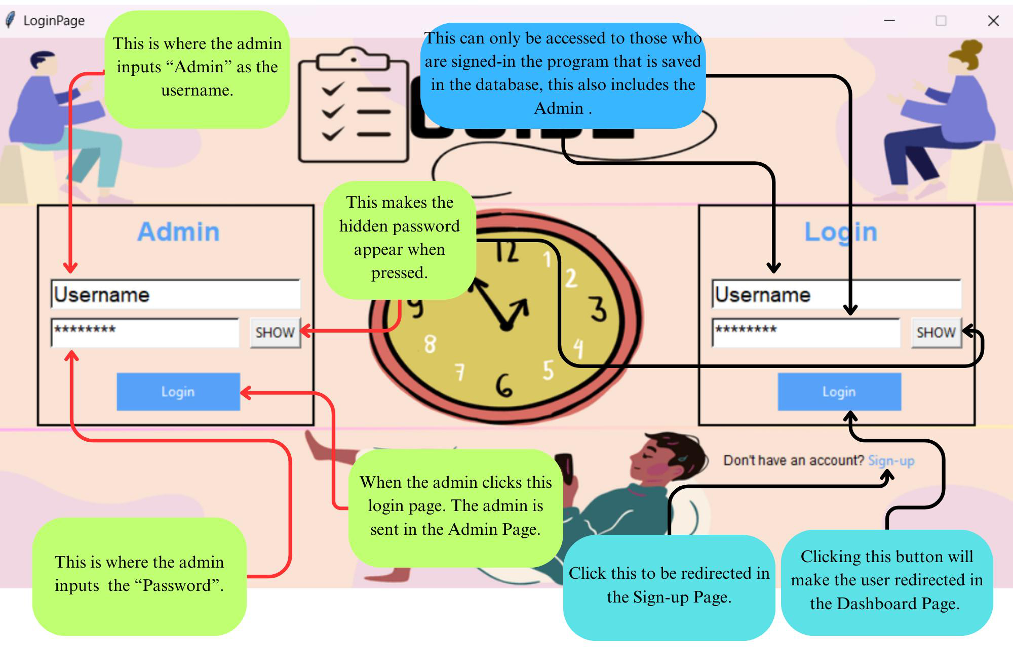

**Figure 1. Login Page**

**1.** The first thing the user need to here is to sign-up by clicking the **“Sign-up Button”. 2.** After clicking the sign-up button the user will be redirected to a page where the user need to fill out information in order to sign-up.

***Leading Innovations, Transforming Lives, Building the Nation***

|  |
| --- |
| E-mail Address: [cics.alangilan@g.batstate-u.edu.ph | Website Address:](mailto:cics.alangilan@g.batstate-u.edu.ph%20|%20Website%20Address:%20) [http://www.batstate-u.edu.ph](http://www.batstateu-u.edu.ph) **Golden Country Homes, Alangilan Batangas City, Batangas, Philippines 4200 The National Engineering University**  Tel Nos.: (+63 43)425-0139 local 2222 / 2223  **Alangilan Campus**  **Republic of the Philippines**  **BATANGAS STATE UNIVERSITY** |

**College of Informatics and Computing Sciences**

**3.** This is what the user will see upon clicking the button. Just follow what is shown in image.

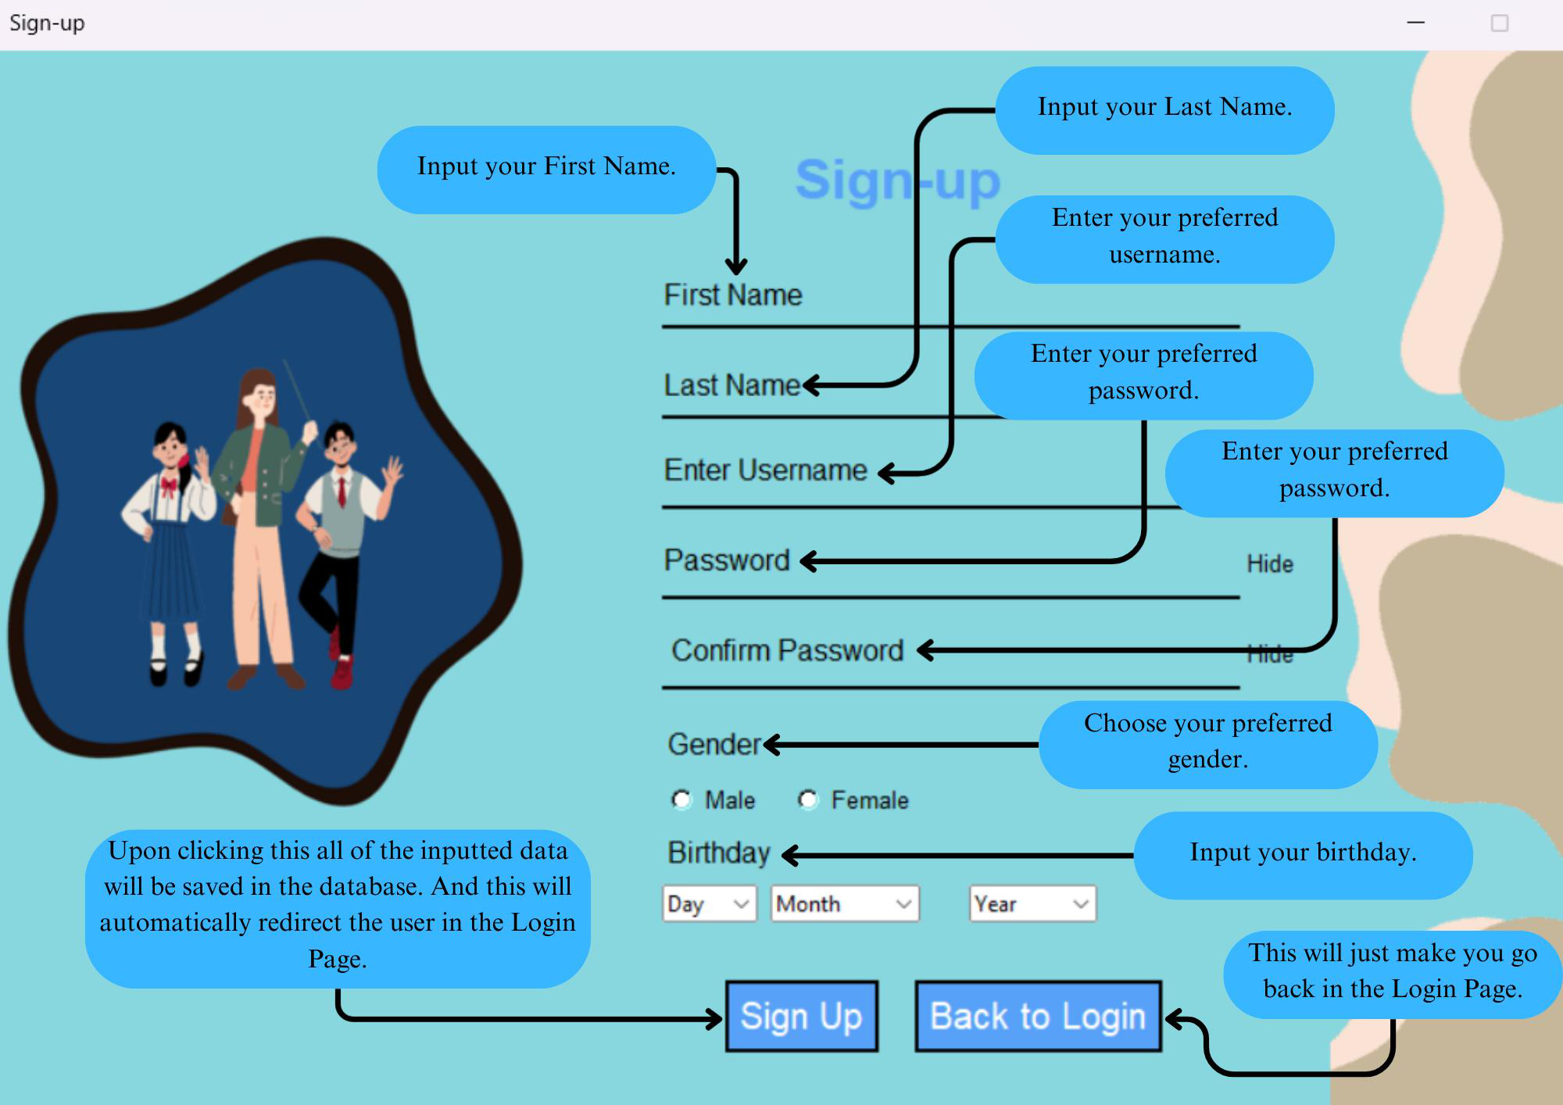

**Figure 2. Sign-up Page**

**4.** After signing-up proceed to login the newly created account. Please refer to **Figure 1. 5.** After logging in, the user will be brought into the Dashboard Page where they can explore freely on that page.

***Leading Innovations, Transforming Lives, Building the Nation***

|  |
| --- |
| E-mail Address: [cics.alangilan@g.batstate-u.edu.ph | Website Address:](mailto:cics.alangilan@g.batstate-u.edu.ph%20|%20Website%20Address:%20) [http://www.batstate-u.edu.ph](http://www.batstateu-u.edu.ph) **Golden Country Homes, Alangilan Batangas City, Batangas, Philippines 4200 The National Engineering University**  Tel Nos.: (+63 43)425-0139 local 2222 / 2223  **Alangilan Campus**  **Republic of the Philippines**  **BATANGAS STATE UNIVERSITY** |

**College of Informatics and Computing Sciences**

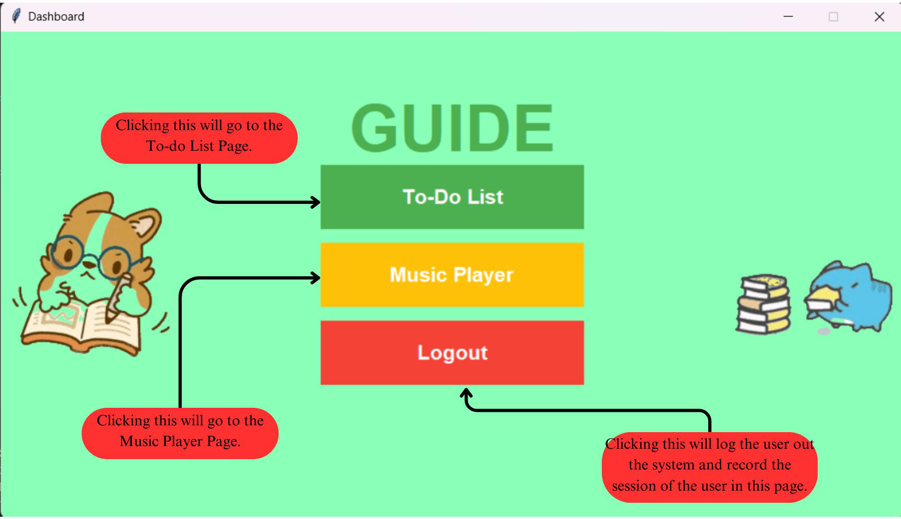

**Figure 3. Dashboard Page**

**6.** Just click either To-Do list or Music Player. If the user prefer silence upon doing their task then it is fine to not go to the music player and proceed to the To-do List. But if the user prefer to have music then feel free to go the music player page.

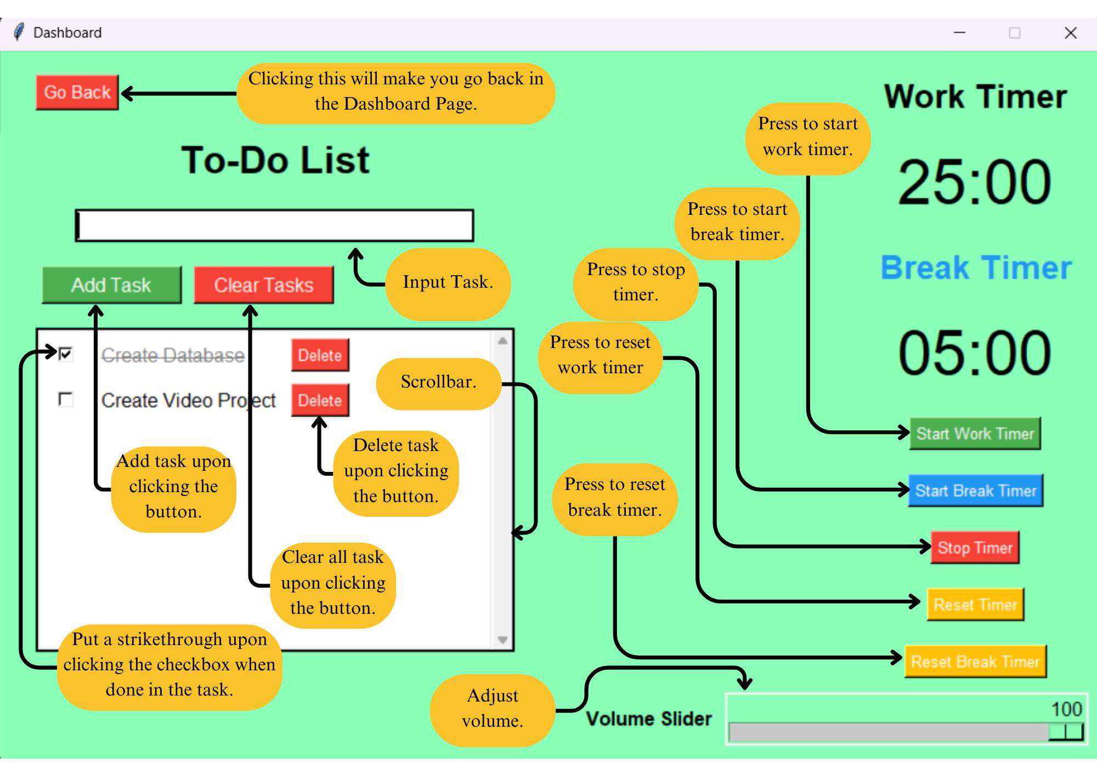

**Figure 4. To-List Page**

***Leading Innovations, Transforming Lives, Building the Nation***

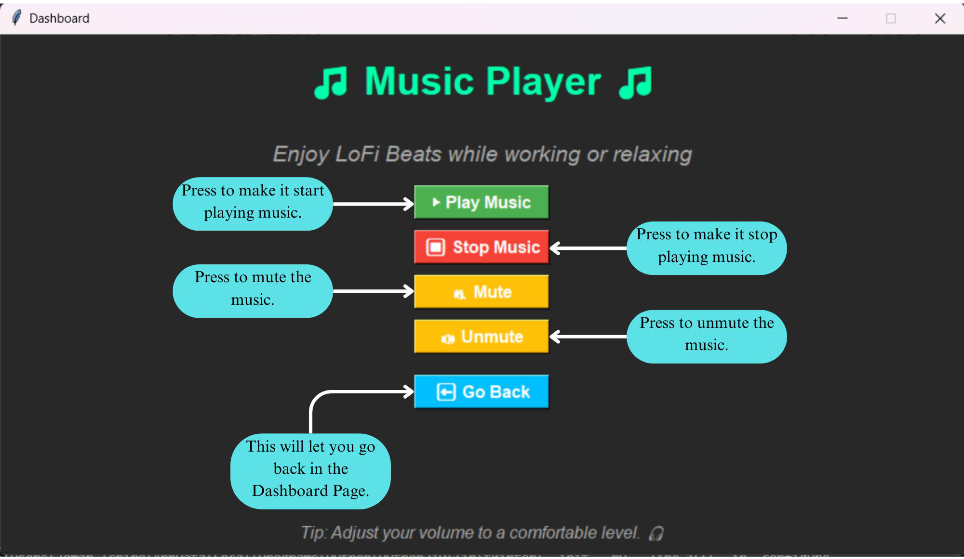

|  |
| --- |
| E-mail Address: [cics.alangilan@g.batstate-u.edu.ph | Website Address:](mailto:cics.alangilan@g.batstate-u.edu.ph%20|%20Website%20Address:%20) [http://www.batstate-u.edu.ph](http://www.batstateu-u.edu.ph) **Golden Country Homes, Alangilan Batangas City, Batangas, Philippines 4200 The National Engineering University**  Tel Nos.: (+63 43)425-0139 local 2222 / 2223  **Alangilan Campus**  **Republic of the Philippines**  **BATANGAS STATE UNIVERSITY** |

**College of Informatics and Computing Sciences**

**Figure 5. Music Player Page**   
**7.** If the user happen to be tha admin and login into the admin section in the Login Page.

Then the admin will go to the **Admin Page.** Please refer to **Figure 1** for references.

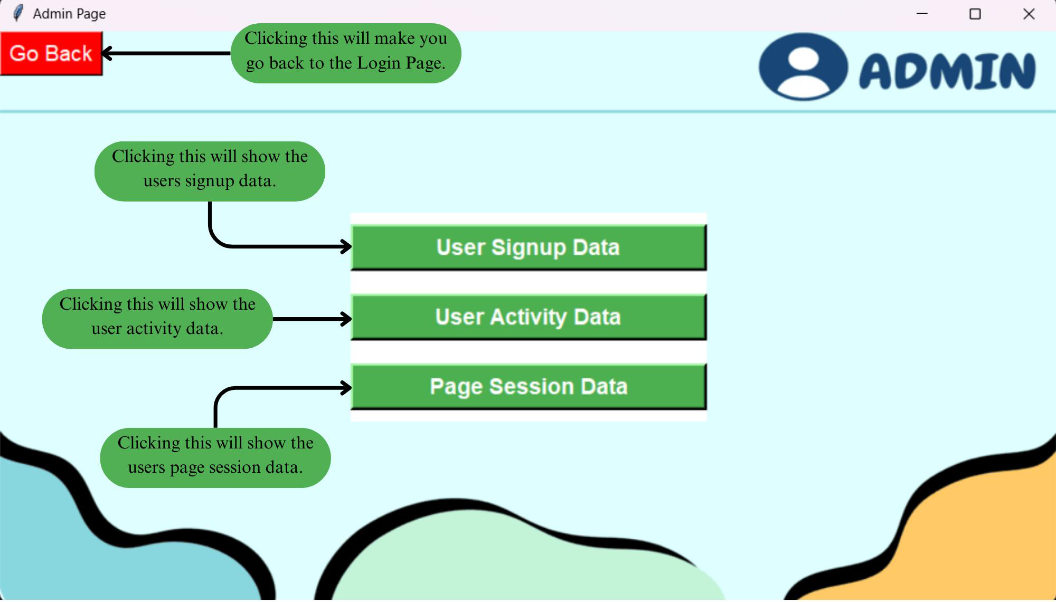

**Figure 6. Admin Page**

**8.** This page is strictly for the usage of only the admin because all of the button shows data of the database that is only for the admin to see.

***Leading Innovations, Transforming Lives, Building the Nation***